CHUNG CHENG HIGH SCHOOL (MAIN)
ADDITIONAL MATHEMATICS
SECONDARY THREE
E-Learning Worksheet (I)

Name: | ( ) |  | Class: | 3 |  | Date:

Objective of Lesson:
Pupils will be able:
- to build the Pascal's Triangle and relate it to the coefficients of Binomial Expansions;
- to derive Binomial Expansions;
- to use the Binomial Theorem to expand expressions in the form (x + y)^{n} where n is a positive integer

Pre-requisites to Lesson:
Go to http://amathhub.tripod.com/ and click on Introduction to Binomial Expansions

DNA Lesson on Binomial Expansions
Instructions to pupils:

Step 1 | : | Log on to DNA (http://schdnaweb.schooldna.com/schooldna/login/login.asp)
Step 2 | : | Click on Search  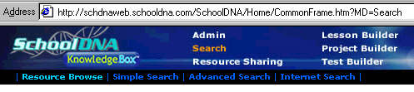
Step 3 | : | Click on Sp/Exp  
Step 4 | : | Scroll down to Binomial Expansions  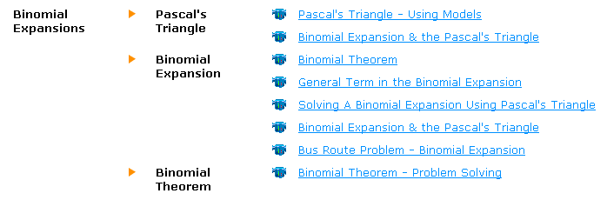
Step 5 | : | Click on Binomial Expansion And The Pascal's Triangle  This website has a video that shows how to build the Pascal's Triangle using Combination. It relates coefficients of the expansion to Pascal's Triangle and shows how to obtain the coefficients of a binomial expansion from the Pascal's Triangle.
Step 6 | : | Click on Binomial Theorem  This website has a video that shows how to derive the simple binomial expansions from area of square and volume of cube. It relates coefficients of the expansion to Pascal's Triangle and shows how to obtain coefficients of binomial expansion from combination. You will discover the patterns in the binomial expansion.  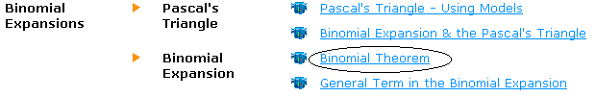
Step 7 | : | Click on Solving A Binomial Expansion Using Pascal’s Triangle  This website has a video that shows how to use the Pascal's Triangle to obtain the coefficients of a binomial expansion.  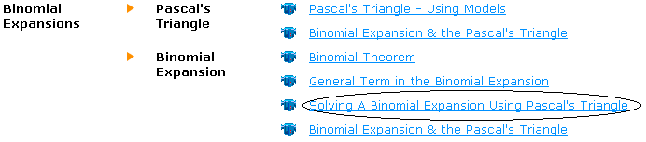

Checklist on your learning:
Answer the following:
1. | What is Pascal’s Triangle made up of?
2. | Write down the coefficients for the expansion (x + y)⁷.
3. | Write down the Binomial Theorem for the expansion (x + y)^{n}.

Worksheet Exercise 1
1. | 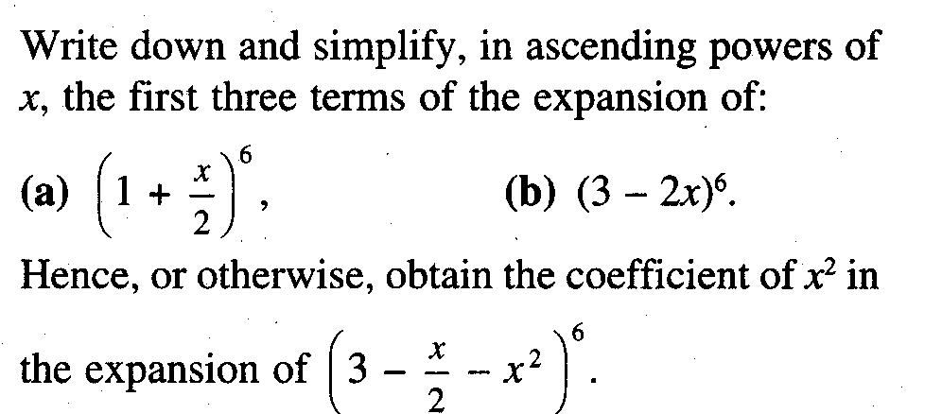
2. | 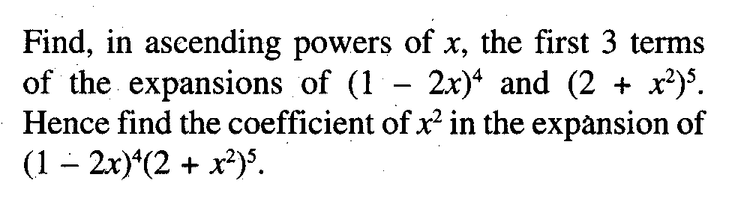
3. | 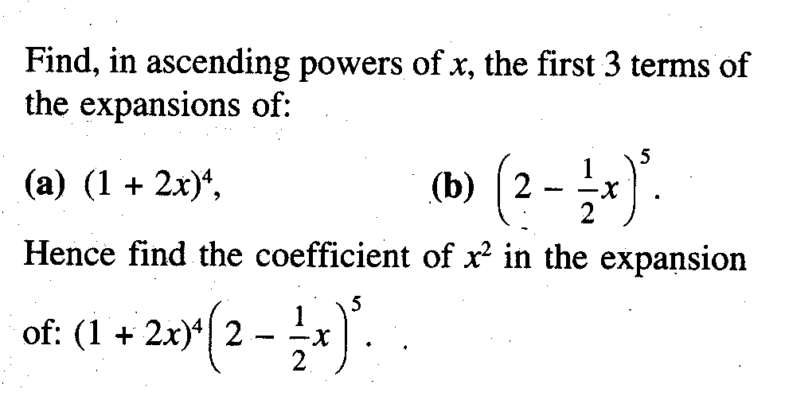
4. | 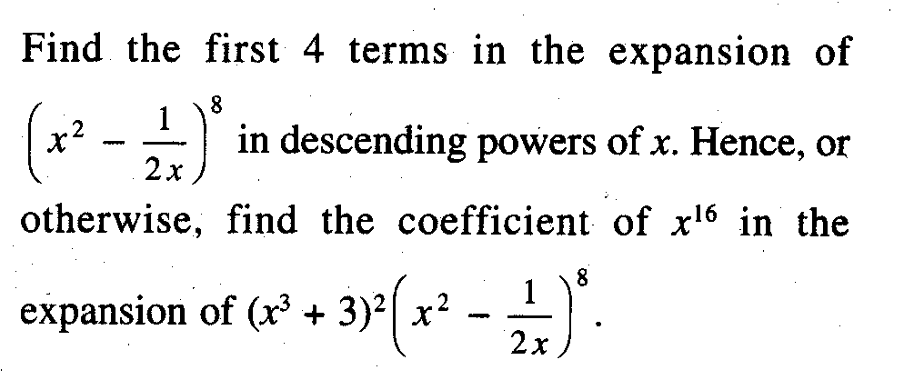
5. | 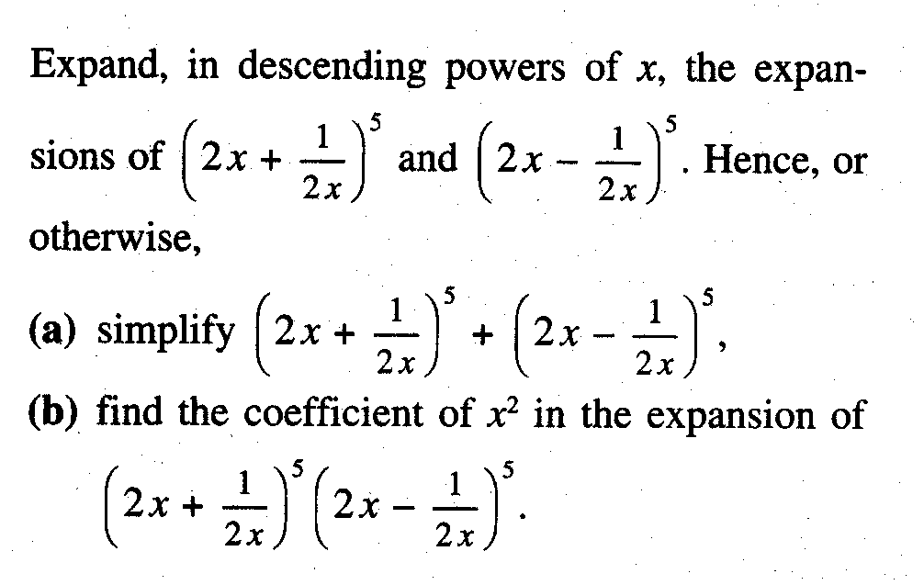

Feedback on Additional Mathematics E-Lesson

- Do you think this is an effective way of learning this topic?
  - If YES,
Reasons: __________________________________________________________

__________________________________________________________________

  - If NO,
Reasons: __________________________________________________________

__________________________________________________________________

- Estimate the time taken to go through and understand the DNA lessons: ______ hrs

- What are some difficulties that you face?

_____________________________________________________________________

_____________________________________________________________________

_____________________________________________________________________

_____________________________________________________________________

_____________________________________________________________________

_____________________________________________________________________

NOTE
There will be test on this worksheet
Either 13 or 14 Nov 2002 (check with your subject teacher)
Get yourself prepared for it!

